Data Flow Diagram and User Stories
Date | 18 June 2026
Team ID
Project Name | ShopEZ – E-Commerce Application
Maximum Marks | 4 Marks

Data Flow Diagram
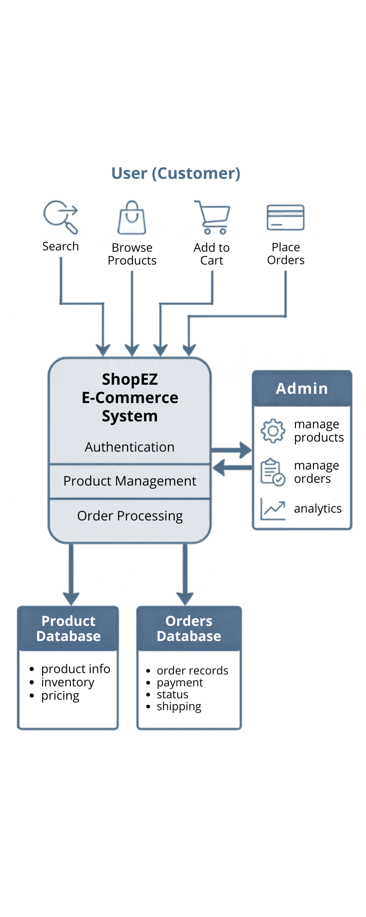

DFD Description
The ShopEZ system allows users to register, log in, browse products, manage carts and wishlists, and place orders. The system stores and retrieves data from the MongoDB database. Administrators manage products and orders through the admin dashboard.

User Stories
User Type | Functional Requirement (Epic) | User Story Number | User Story / Task | Acceptance Criteria | Priority | Release
Customer (Web User) | Registration | USN-1 | As a user, I can register using my name, email, and password. | User account is created successfully. | High | Sprint-1
Customer (Web User) | Login | USN-2 | As a user, I can log in using valid credentials. | User is redirected to the home page. | High | Sprint-1
Customer (Web User) | Product Management | USN-3 | As a user, I can view all available products. | Products are displayed correctly. | High | Sprint-2
Customer (Web User) | Product Search | USN-4 | As a user, I can search for products. | Matching products are displayed. | High | Sprint-2
Customer (Web User) | Category Filter | USN-5 | As a user, I can filter products by category. | Products are filtered correctly. | Medium | Sprint-2
Customer (Web User) | Cart | USN-6 | As a user, I can add products to my cart. | Selected products appear in the cart. | High | Sprint-3
Customer (Web User) | Cart | USN-7 | As a user, I can update product quantities in the cart. | Cart quantities update successfully. | Medium | Sprint-3
Customer (Web User) | Wishlist | USN-8 | As a user, I can add products to my wishlist. | Products appear in the wishlist. | High | Sprint-3
Customer (Web User) | Wishlist | USN-9 | As a user, I can move wishlist items to the cart. | Selected items move successfully. | Medium | Sprint-3
Customer (Web User) | Orders | USN-10 | As a user, I can place orders. | Order is stored successfully. | High | Sprint-4
Customer (Web User) | Orders | USN-11 | As a user, I can view my order history. | User orders are displayed. | Medium | Sprint-4
Administrator | Product Management | USN-12 | As an admin, I can add new products. | Product is added successfully. | High | Sprint-4
Administrator | Product Management | USN-13 | As an admin, I can update products. | Product details are updated. | Medium | Sprint-4
Administrator | Product Management | USN-14 | As an admin, I can delete products. | Product is removed successfully. | Medium | Sprint-4
Administrator | Order Management | USN-15 | As an admin, I can view and manage orders. | Orders are displayed and updated successfully. | High | Sprint-4

